**Web Lab**

**Lab No.3**

## Task 1:



Code:

<!DOCTYPE html>

<html lang="en">

<head>

    <meta charset="UTF-8">

    <meta name="viewport" content="width=device-width, initial-scale=1.0">

    <title>Order List</title>

    <style>

        #container{

            display:flex;

            width: 100%;

        }

        #left-panel,#right-section {

            padding: 20px;

            width: 50%;

            box-sizing: border-box;

        }

    </style>

</head>

<body>

    <div id="container">

        <div id="left-panel" style="background-color: chocolate;">

            <ol>

                <li>Web Dev</li>

                <li>Cricket</li>

                <li>Football</li>

                <li>Video Gaming</li>

                <li>Programing</li>

            </ol>

        </div>

        <div id="right-section" style="background-color: rgb(205, 243, 243); display: flex; flex-direction: row-reverse;">

            <ol type="A">

                <li>Web Dev</li>

                <li>Cricket</li>

                <li>Football</li>

                <li>Video Gaming</li>

                <li>Programing</li>

            </ol>

        </div>

    </div>

<div id="container">

        <div id="left-panel" style="background-color: aqua; display: flex; flex-direction: row-reverse;">

            <ol type="a">

                <li>Web Dev</li>

                <li>Cricket</li>

                <li>Football</li>

                <li>Video Gaming</li>

                <li>Programing</li>

            </ol>

        </div>

        <div id="right-section" style="background-color: rgb(152, 202, 34);">

            <ol type="i">

                <li>Web Dev</li>

                <li>Cricket</li>

                <li>Football</li>

                <li>Video Gaming</li>

                <li>Programing</li>

            </ol>

        </div>

    </div>

</body>

</html>

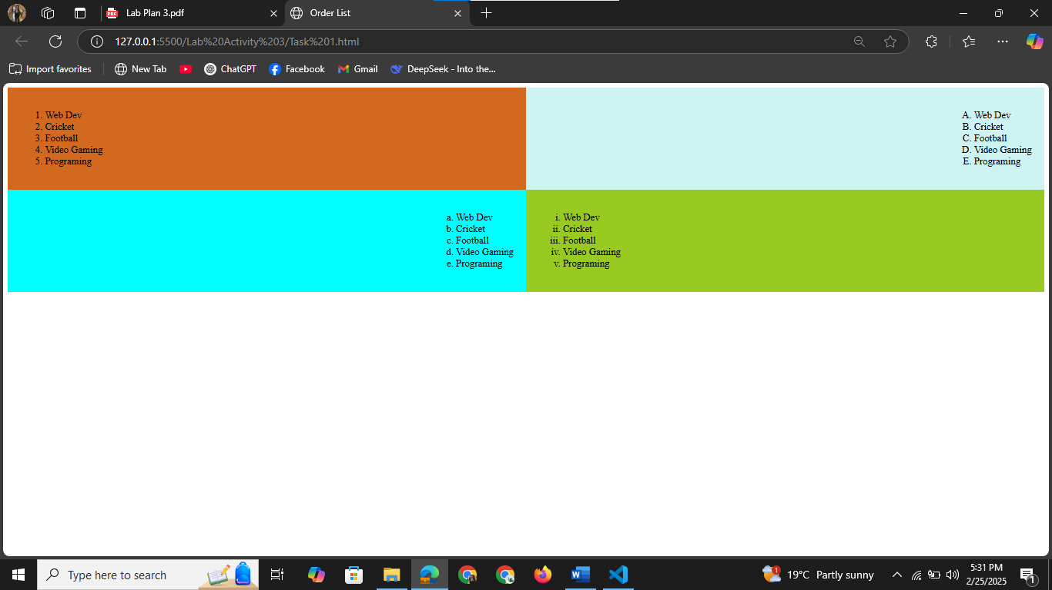

## Task 2:



Code:

<!DOCTYPE html>

<html lang="en">

<head>

    <meta charset="UTF-8">

    <meta name="viewport" content="width=device-width, initial-scale=1.0">

    <title>Task 2</title>

</head>

<body>

    <ul type="square">

        <li>Apple

        <li>Kiwi

        <li>Mango

        <li>Orange

        <li>Banana

        <li>Date

        <li>Peer

    </ul>

</body>

</html>

## Task 3:

Code:

<!DOCTYPE html>

<html lang="en">

<head>

    <meta charset="UTF-8">

    <meta name="viewport" content="width=device-width, initial-scale=1.0">

    <title>Task 3</title>

</head>

<body>

    <h2>Ordered List Starting from 10</h2>

    <ol start="10">

        <li>Web Development</li>

        <li>Cricket</li>

        <li>Football</li>

        <li>Video Gaming</li>

        <li>Programming</li>

    </ol>

</body>

</html>

## Task 4:



Code:

<!DOCTYPE html>

<html lang="en">

<head>

    <meta charset="UTF-8">

    <meta name="viewport" content="width=device-width, initial-scale=1.0">

    <title>Mypage</title>

</head>

<body>

    <h2>Ordered List Starting from 10</h2>

    <ol type="i" start="10" style="color: red;">

        <li>Web Development</li>

        <li>Cricket</li>

        <li>Football</li>

        <li>Video Gaming</li>

        <li>Programming</li>

    </ol>

</body>

</html>

## Task 5:

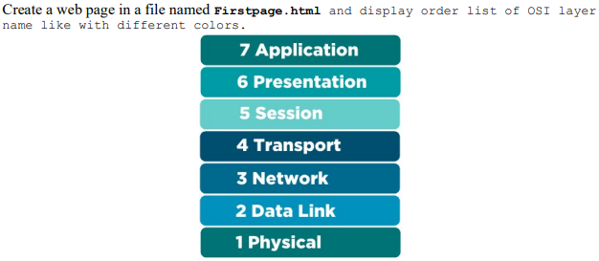

Code:

<!DOCTYPE html>

<html lang="en">

<head>

    <meta charset="UTF-8">

    <meta name="viewport" content="width=device-width, initial-scale=1.0">

    <title>OSI Model Layers</title>

    <style>

        body{

            font-family: 'Times New Roman', Times, serif;

            text-align: center;

        }

        ol {

            padding: 0;

            width: 300px;

            margin: auto;

            list-style-position: inside;

        }

        li{

            margin:2px 0;

            padding: 20px;

            color:white;

            font-weight: bold;

            font-size: 18px;

            border-radius: 5px;

        }

    </style>

</head>

<body>

    <h2>Ordered List of OSI Layers</h2>

    <ol reversed>

        <li style="background-color: rgb(129, 245, 229);">Physical</li>

        <li style="background-color: rgb(240, 121, 67);">DataLink</li>

        <li style="background-color: rgb(54, 65, 128);">Network</li>

        <li style="background-color: rgb(138, 53, 71);">Transport</li>

        <li style="background-color: rgb(188, 52, 206);">Session</li>

        <li style="background-color: rgb(204, 245, 129);">Presentation</li>

        <li style="background-color: rgb(238, 152, 241);">Application</li>

    </ol>

</body>

</html>

## Task 6:

Code:

<!DOCTYPE html>

<html lang="en">

<head>

    <meta charset="UTF-8">

    <meta name="viewport" content="width=device-width, initial-scale=1.0">

    <title>Unordered nested list</title>

</head>

<body>

    <p>GeeksforGeeks Course list</p>

    <ul>

        <li>DSA

            <ul type="circle">

                <li>Array

                <li>Link-list

                <li>Stack

                <li>Queue

            </ul>

        <li>Web Technologies

            <ul type="circle">

                <li>HTML

                <li>CSS

                <li>Java-Script

            </ul>

        <li>Aptitude

        <li>Gate

        <li>Placement

    </ul>

</body>

</html>

## Task 7:

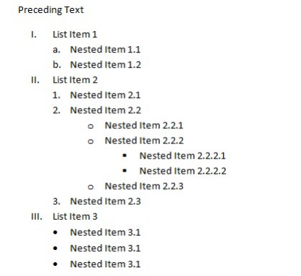

Code:

<!DOCTYPE html>

<html lang="en">

<head>

    <meta charset="UTF-8">

    <meta name="viewport" content="width=device-width, initial-scale=1.0">

    <title>Task 7</title>

</head>

<body>

    <ol type="i">

        <li>List item 1</li>

        <ol type="a">

            <li>Nested item 1.1</li>

            <li>Nested item 1.2</li>

        </ol>

        <li>List item 2</li>

        <ol>

            <li>Nested item 2.1</li>

            <li>Nested item 2.2</li>

            <ul type="circle">

                <li>Nested item 2.2.1</li>

                <li>Nested item 2.2.2</li>

                <ul type="square">

                    <li>Nested item 2.2.2.1</li>

                    <li>Nested item 2.2.2.2</li>

                </ul>

            </ul>

            <li>Nested item 2.3</li>

        </ol>

        <li>List item 3</li>

        <ul type="disc">

            <li>Nested item 3.1</li>

            <li>Nested item 3.2</li>

            <li>Nested item 3.3</li>

        </ul>

    </ol>

</body>

</html>

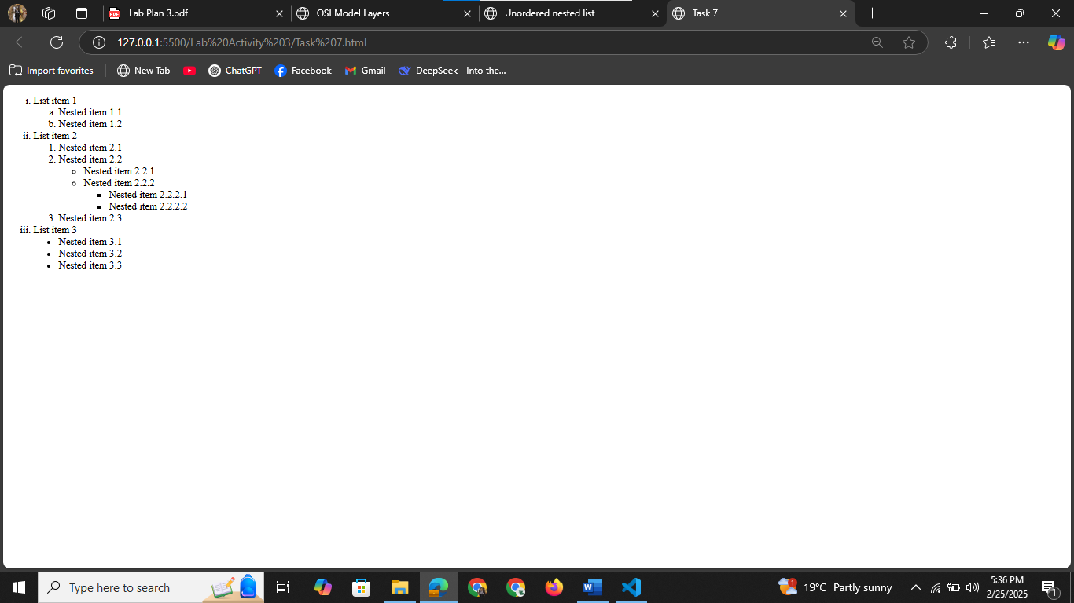

## Task 8:

Code:

<!DOCTYPE html>

<html lang="en">

<head>

    <meta charset="UTF-8">

    <meta name="viewport" content="width=device-width, initial-scale=1.0">

    <title>Document</title>

</head>

<body>

    <h1>Welcome!</h1>

    <img src="image.jpeg" alt="image">

    <p>The image appears to show a plant in focus with the sun setting or rising in the background, creating a warm and peaceful atmosphere. It likely represents themes of nature, growth, and tranquility. Let me know if you need any specific analysis or modifications!</p>

</body>

</html>

## Task 9:



Code:

<!DOCTYPE html>

<html lang="en">

<head>

    <meta charset="UTF-8">

    <meta name="viewport" content="width=device-width, initial-scale=1.0">

    <title>Task 9</title>

</head>

<body>

    <div style="display: flex;">

    <img src="img1.jpeg" alt="image">

    <p style="display: flex;">The image appears to show a plant in focus with the sun setting or rising in the background, creating a warm and peaceful atmosphere. It likely represents themes of nature, growth, and tranquility. Let me know if you need any specific analysis or modifications!</p>

</div>

</body>

</html>

## Task 10:

Code:

<!DOCTYPE html>

<html lang="en">

<head>

    <meta charset="UTF-8">

    <meta name="viewport" content="width=device-width, initial-scale=1.0">

    <title>Task 10</title>

</head>

<body>

    <h1>Compare-Write about things that are similar or the same</h1>

    <div style="display: flex;">

        <img src="image1.jpeg" alt="image">

        <ol>

        <p >Paragraph Structure</p>

            <li>Topic sentence</li>

            <li>3-4 sentences about things they do, like or have that are the same</li>

            <li>Concluding sentences</li>

        </ol>

    </div>

</body>

</html>

**Lab No.4**

## Task 1:



Code:

<!DOCTYPE html>

<html lang="en">

<head>

    <meta charset="UTF-8">

    <meta name="viewport" content="width=device-width, initial-scale=1.0">

    <title>Task 1</title>

</head>

<body>

    <ul type="square">

        <li>Apple

        <li>Mango

        <li>Orange

        <li>Banana

        <li>Date

    </ul>

</body>

</html>

## Task 2:



Code:

<!DOCTYPE html>

<html lang="en">

<head>

    <meta charset="UTF-8">

    <meta name="viewport" content="width=device-width, initial-scale=1.0">

    <title>Task 2</title>

</head>

<body>

    <h3>Student Names </h3>

    <ul type="circle">

        <li>Zahid</li>

        <li>Ali</li>

        <li>Usman</li>

        <li>Khalid</li>

    </ul>

<h3>City Names (Disc Marker)</h3>

    <ul type="disc">

        <li>Faisalabad</li>

        <li>Lahore</li>

        <li>Karachi</li>

    </ul>

</body>

</html>

## Task 3:

Code:

<!DOCTYPE html>

<html lang="en">

<head>

    <meta charset="UTF-8">

    <meta name="viewport" content="width=device-width, initial-scale=1.0">

    <title>Task 3</title>

</head>

<body>

    <h2>Student Name</h2>

    <ol >

        <li value="1">Zahid</li>

        <li value="3">Ali</li>

        <li value="6">Usman</li>

        <li value="7">Khalid</li>

        <li value="9">Zeeshan</li>

    </ol>

</body>

</html>

## Task 4:



Code:

<!DOCTYPE html>

<html lang="en">

<head>

    <meta charset="UTF-8">

    <meta name="viewport" content="width=device-width, initial-scale=1.0">

    <title>Mylist</title>

    <style>

        ol{

            color: green;

            font-family: Algerian;

            size: +3;

        }

    </style>

</head>

<body>

    <ol type="a" start="7">

        <li>App Development</li>

        <li>Web Development</li>

        <li>AI Agents</li>

    </ol>

</body>

</html>

## Task 5:

Code:

<!DOCTYPE html>

<html lang="en">

<head>

    <meta charset="UTF-8">

    <meta name="viewport" content="width=device-width, initial-scale=1.0">

    <title>Document</title>

    <style>

        body {

            font-family: Arial, sans-serif;

        }

        .container {

            display: flex;

            justify-content: space-between;

        }

        .list-section {

            width: 45%;

        }

        h2 {

            text-align: center;

        }

    </style>

</head>

<body>

    <div class="container">

        <div class="list-section">

          <h2>Unordered lists</h2>

            <h3>Disc</h3>

            <ul type="disc">

                <li>First item</li>

                <li>Second item</li>

                <li>Third item</li>

            </ul>

            <h3>Square</h3>

            <ul type="Square">

                <li>First item</li>

                <li>Second item</li>

                <li>Third item</li>

            </ul>

            <h3>Circle</h3>

            <ul type="Circle">

                <li>First item</li>

                <li>Second item</li>

                <li>Third item</li>

            </ul>

            <h3>None - no bullets</h3>

            <ul>

                <li>First item</li>

                <li>Second item</li>

                <li>Third item</li>

            </ul>

        </div>

        <div class="list-section">

            <h2>Ordered lists</h2>

            <h3>Decimal</h3>

            <ol>

                <li>First item</li>

                <li>Second item</li>

                <li>Third item</li>

            </ol>

            <h3>Decimal with leading zeros</h3>

            <ol style="list-style-type: decimal-leading-zero;">

                <li>First item</li>

                <li>Second item</li>

                <li>Third item</li>

            </ol>

            <h3>Lowercase ASCII letters</h3>

            <ol type="a">

                <li>First item</li>

                <li>Second item</li>

                <li>Third item</li>

            </ol>

            <h3>Lowercase Roman numerals</h3>

            <ol type="i">

                <li>First item</li>

                <li>Second item</li>

                <li>Third item</li>

            </ol>

        </div>

    </div>

</body>

</html>

## Task 6:

Code:

<!DOCTYPE html>

<html lang="en">

<head>

    <meta charset="UTF-8">

    <meta name="viewport" content="width=device-width, initial-scale=1.0">

    <title>Task 6</title>

</head>

<body>

    <ol start="107">

        <li>English First paper</li>

        <ul type="square">

            <li>True/False</li>

            <li>Fill in the gap</li>

        </ul>

        <li>English Second paper</li>

        <ul>

            <li>Gramar Section</li>

            <ol type="a">

                <li>Article</li>

                <li>Narration</li>

                <li>Preposition</li>

            </ol>

            <li>Writing Section</li>

        </ul>

    </ol>

</body>

</html>

## Task 7:

Code:

<!DOCTYPE html>

<html lang="en">

<head>

    <meta charset="UTF-8">

    <meta name="viewport" content="width=device-width, initial-scale=1.0">

    <title>Task 7</title>

</head>

<body>

    <h1>List Example</h1>

    <ol type="1">

        <li>List item 1</li>

        <ol type="A">

            <li>Nested item 1.1</li>

            <li>Nested item 1.2</li>

        </ol>

        <li>List item 2</li>

        <ol type="1">

            <li>Nested item 2.1</li>

            <li>Nested item 2.2</li>

            <ul type="square">

                <li>Nested item 2.2.1</li>

                <li>Nested item 2.2.2</li>

                <ul type="circle">

                    <li>Nested item 2.2.2.1</li>

                    <li>Nested item 2.2.2.2</li>

                </ul>

                <li>Nested item 2.2.3</li>

            </ul>

            <li>Nested item 2.3</li>

        </ol>

        <li>List item 3</li>

        <ul type="disc">

            <li>Nested item 3.1</li>

            <li>Nested item 3.2</li>

            <li>Nested item 3.3</li>

        </ul>

    </ol>

</body>

</html>

## Task 8:

Code:

<!DOCTYPE html>

<html lang="en">

<head>

    <meta charset="UTF-8">

    <meta name="viewport" content="width=device-width, initial-scale=1.0">

    <title>Task 8</title>

    <style>

        .header {

    display: flex;

}

.logo-text {

    font-size: 40px;

}

.text {

    font-size: large;

}

hr {

    border: none;

    height: 3.5px;

    background-color: gray;

}

.container{

    display: inline-flex; }

.image-content img{

    margin-left: 100px;

    margin-right: 200px;

    height: 100px;

    width: 300px;

}

    </style>

</head>

<body>

    <div class="header">

        <img src="leaf.jpeg" alt="leaf img">

        <div>

            <div class="logo-text">The Garden Company</div>

            <div class="text"><i>Helping you help your gardens grow since 1975</i></div>

        </div>

    </div>

    <hr>

    <div class="container">

        <div>

            <p><b>Trees, including peach, pear, apple, and plum trees, are currently in stock.</b>These trees feature sturdy root systems and healthy foliage, with prices starting at $29.99. Additional details can be found on the Products page.New articles on "Diagnosing Foliage Problems" and "Spraying Techniques for Fruit Trees" are also available. Visit the <a href="www.product.com">product</a> page for detail.</p>

            <p><b>New articles!</b> Check out these recently posted articles:</p>

            <ul>

                <li><a href="#">Diagnosing Foliage Problems</a></li>

                <li><a href="#">Spraying Techniques for Fruit Trees</a></li>

            </ul>

<p><b>What does that mean?</b> Run into an unfamiliar gardening term? Look it up in our <a

                    href="#">Glossary</a>.</p>

        </div>

        <div class="image-content">

        <img src="html,css,js logo.png" alt="logo">

        </div>

    </div>

</body>

</html>

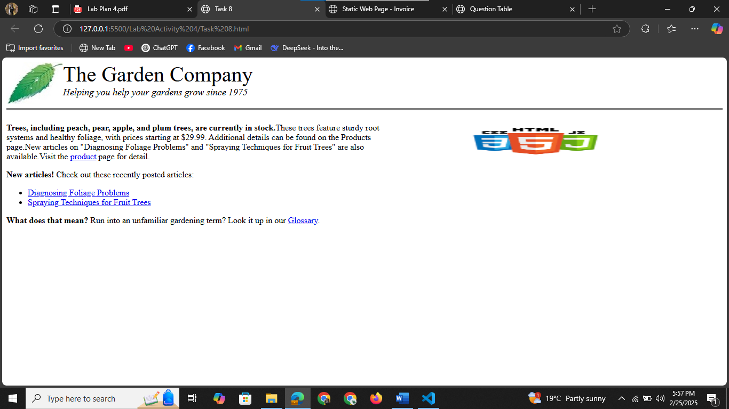

## Task 9:

Code:

<!DOCTYPE html>

<html lang="en">

<head>

    <meta charset="UTF-8">

    <meta name="viewport" content="width=device-width, initial-scale=1.0">

    <title>Static Web Page - Invoice</title>

    <style>

        body {

            font-family: Arial, sans-serif;

            margin: 20px;

        }

        .container{

            border: 3px solid blue;

        }

        table {

            width: 100%;

            border-collapse: separate;

        }

        th, td {

            border: 3px  blue double;

            padding: 10px;

            text-align: left;

        }

        th {

            background-color: #f2f2f2;

        }

        .header {

            text-align: center;

            font-weight: bold;

            margin-bottom: 10px;

        }

    </style>

</head>

<body>

    <h2 class="header">Advanced HTML tag for Table using thead, tbody, and tfoot</h2>

    <div class="container">

    <table>

        <thead>

            <tr>

                <th colspan="3" style="text-align: center;">Purchase order: 987654321</th>

                <th colspan="1" style="text-align: center;">Tutorialbrain - 10th Oct 2020</th>

            </tr>

        </thead>

        <tbody>

            <tr>

                <td colspan="2"><strong>Vendor:</strong><br>ABC XYZ Ltd.<br>DUMMY STREET<br>BUILDING 123<br>HAZARIBAGH, JHARKHAND, 825301</td>

                <td colspan="2"><strong>SHIP TO:</strong><br>MS DHONI<br>WILSON GARDEN<br>SOUTHEAST BLOCK, RANCHI - 834001</td>

            </tr>

            <tr>

                <th style="text-align: center;">Qty.</th>

                <th style="text-align: center;">Item Code.</th>

                <th style="text-align: center;">Description</th>

                <th style="text-align: center;">Unit Price</th>

            </tr>

            <tr>

                <td>100</td>

                <td>IABCDE</td>

                <td>Pencils</td>

                <td>20.00</td>

            </tr>

            <tr>

                <td>1000</td>

                <td>IN877</td>

                <td>Notebooks</td>

                <td>100.00</td>

            </tr>

            <tr>

                <td>500</td>

                <td>IP8675</td>

                <td>Pens</td>

                <td>70.00</td>

            </tr>

        </tbody>

        <tfoot>

            <tr>

                <td colspan="3" style="text-align: center;"><strong>Subtotal</strong></td>

                <td>190.00</td>

            </tr>

            <tr>

                <td colspan="2" style="text-align: center;"><strong>GST</strong></td>

                <td>5%</td>

                <td>9.50</td>

            </tr>

            <tr>

                <td colspan="3" style="text-align: center;"><strong>Grand Total</strong></td>

                <td>$ 199.50</td>

            </tr>

        </tfoot>

    </table>

</div>

</body>

</html>

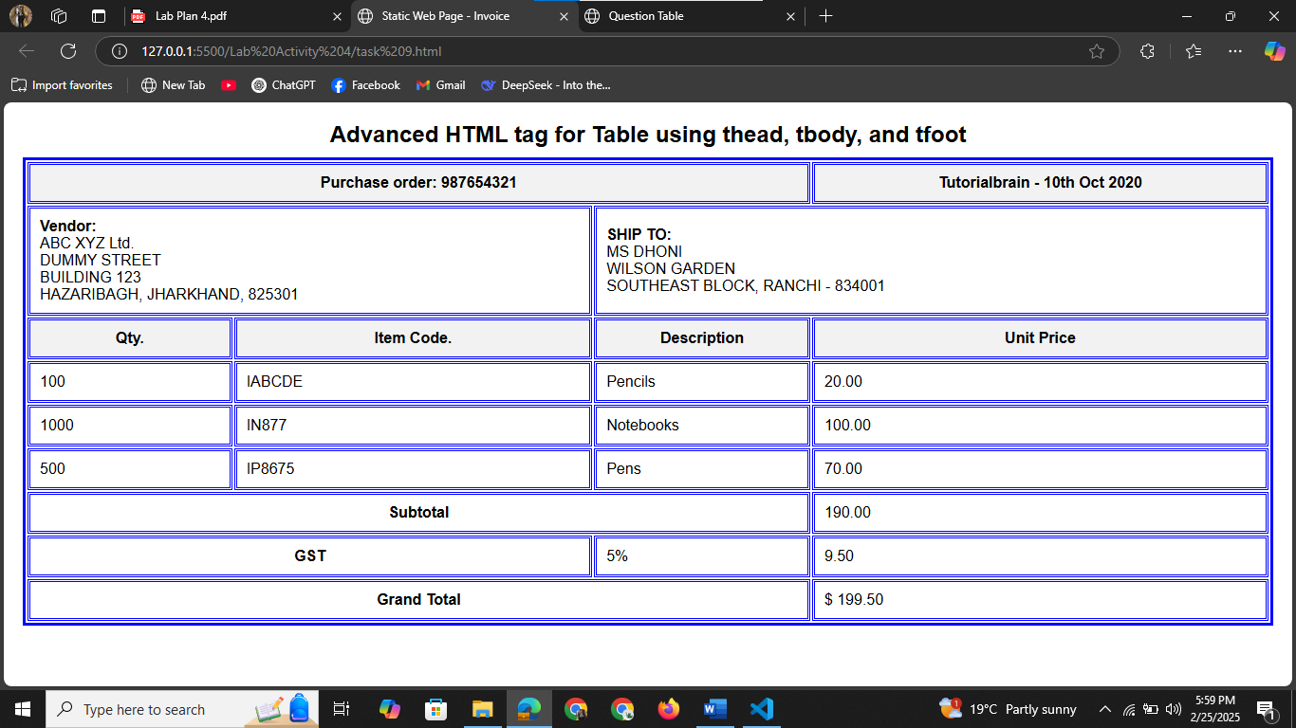

## Task 10:



Code:

<!DOCTYPE html>

<html lang="en">

<head>

    <meta charset="UTF-8">

    <meta name="viewport" content="width=device-width, initial-scale=1.0">

    <title>Question Table</title>

    <style>

        table {

            width: 100%;

            border-collapse: separate;

            border-spacing: 0;

            border: 5px groove rgb(223, 208, 208);

        }

        th, td {

            border: 3px groove rgb(223, 208, 208);

            padding: 10px;

            text-align: left;

            background-color: white;

        }

        th {

            border-bottom: 5px groove rgb(223, 208, 208); }

        input[type="text"] {

            height: 100%;

            width: 100%;

            box-sizing:border-box;

            border: none;

            padding: 5px; }

      </style>

</head>

<body>

    <table>

        <tr>

            <th>Question No.</th>

            <th>Question</th>

            <th>Answer</th>

            <th>Marks per Answer</th>

            <th>Total Marks</th>

        </tr>

        <tr>

            <td rowspan="3">1</td>

            <td rowspan="3">Name three features in a ROM</td>

            <td>A</td>

            <td rowspan="1"><input type="text"></td>

            <td rowspan="3">5</td>

        </tr>

        <tr>

            <td>B</td>

          <td><input type="text"></td>

        </tr>

        <tr>

            <td>D</td>

          <td><input type="text"></td>

        </tr>

        <tr>

            <td>2</td>

            <td>Here is a single answer</td>

            <td>True</td>

            <td><input type="text"></td>

            <td>5</td>

        </tr>

    </table></body>

</html>

